**Artificial Intelligence Assignment 1**

1. Describe the problem formulation steps in AI with examples.
2. What are the branches of AI? Explain in brief.
3. Find a path between nodes A and G using BFS for the given tree.

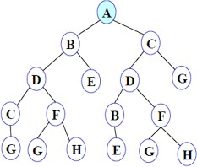

1. Solve the given 8-puzzle problem.

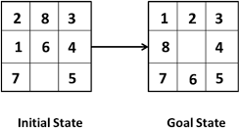

1. What do you mean by Blind search? Explain different types of Blind search with an example.
2. Discuss various steps in problem-solving techniques.
3. Explain the concept of Production Systems in AI in detail.
4. What do you mean by heuristic and heuristic search techniques?
5. What is the need for the evaluation function?
6. What do you mean by problem reduction? Explain with the help of an AND-OR graph.
7. 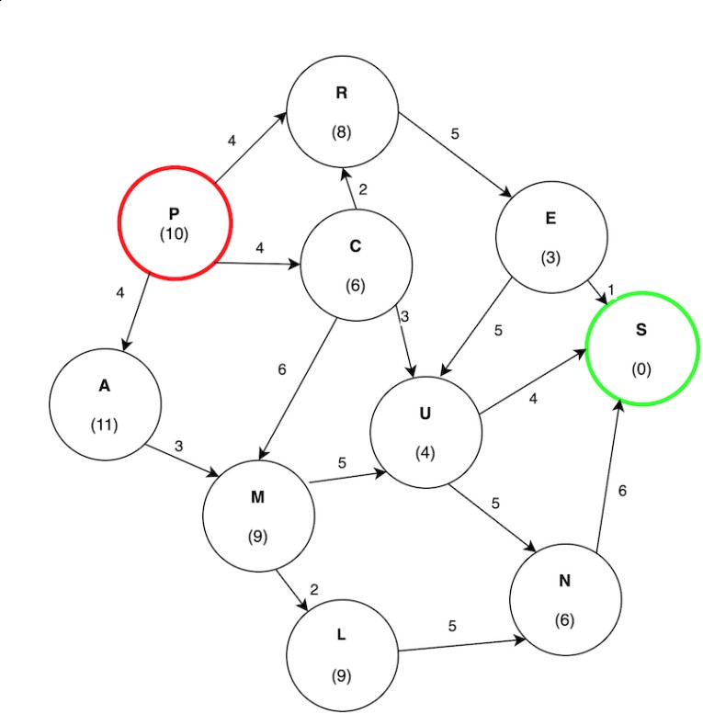Find the path from P to S from the following graph by using the best-first search algorithm.
8. What is a state-space diagram for the Hill-climbing algorithm? Explain all the regions in the state-space diagram of the Hill-climbing algorithm.
9. Consider the following graph. The numbers written on nodes represent the heuristic value.

Find the most cost-effective path to reach from start state A to final state J using A* algorithm.

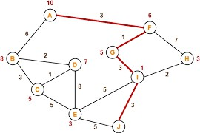

1. Find the path to reach goal node G from A by using the Breadth First Search algorithm on the following graph.



1. Find the final solution path by using the Best First Search on following graph.

